 | 10.1.18 Editors - Compositor Editor - Header - Add Menu - Utilities - Math
Table of content
Detailed table of content 1
Add menu - Utilities - Math 3
Clamp 3
Float Curve 4
Map Range 6
Math 7
Mix 8

Detailed table of content
Detailed table of content
Detailed table of content 1
Add menu - Utilities - Math 3
Clamp 3
Inputs 3
Value 3
Properties 3
Clamp Type 3
Min / Max 3
Outputs 3
Value 3
Float Curve 4
Inputs 4
Factor 4
Value 4
Properties 4
Curve edit field 4
Selecting Points 4
Adding Points 4
Zoom in and out 4
Tools 4
Reset View 4
Extend horizontal 5
Extend extrapolated 5
Reset Curve 5
Clipping Options 5
Use Clipping 5
Delete Points 5
Vector Handle 5
Auto Handle 5
Auto Clamped Handle 5
X / Y value 5
Delete 5
Outputs 5
Value 5
Map Range 6
Usage 6
Inputs 6
Value 6
From Min/Max 6
To Min/Max 6
Steps 6
Properties 6
Data Type 6
Interpolation Type 6
Clamp 6
Outputs 7
Value 7
Math 7
Inputs 7
Value 7
Value 7
Properties 7
Operation 7
Clamp 7
Outputs 7
Value 7
Mix 8
Inputs 8
Factor 8
Value A 8
Value B 8
Properties 8
Clamp Factor 8
Outputs 8
Result 8

Add menu - Utilities - Math
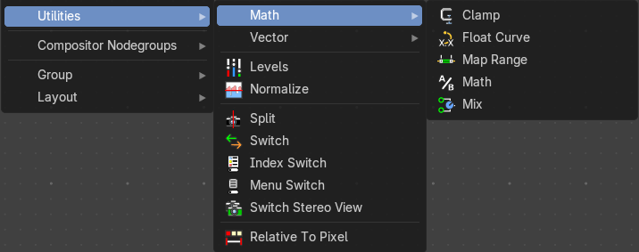

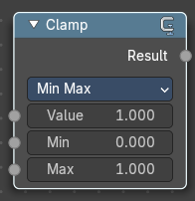
Clamp
The Clamp node restricts a value to lie within a specified range. It’s commonly used in compositing to prevent values from exceeding a desired minimum or maximum, which helps avoid unwanted brightness spikes or clipping in image processing.

Inputs

Value
Standard Value input. (Value refers to each vector in the set.)

Properties

Clamp Type
A dropdown that determines how the clamping is applied: Min / Max or Range.

Min / Max
The minimum and maximum allowed value. Any input lower or higher than this will be lowered or raised to this value.

Outputs

Value
Standard value output.

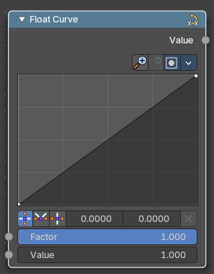
Float Curve
The Float Curves node maps an input value to a curve.

Inputs

Factor
Input factor.

Value
Standard float value input.

Properties

Curve edit field
Create and tweak a Bezier curve that varies the input levels (X axis) to produce an output level (Y axis).


Selecting Points
You can select curve points. This reveals two edit boxes for the x and y coordinate of this point.
Selected points can be moved around. Left click at them, hold the mouse button down and move them to a new location.


Adding Points
You can add new curve points by simply left clicking at the curve. Move the mouse to position them where you need it.

Zoom in and out
The two buttons with the magnifying glass at it zooms in and out in the curve window.

Tools
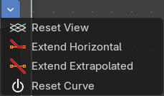
Tools is a menu where you can find some curve related tools.

Reset View
Resets the curve windows zoom.

Extend horizontal
Extends the curve before the first curve point and behind the last curve point horizontally.

Extend extrapolated
Extends the curve before the first curve point and behind the last curve point extrapolated.

Reset Curve
Resets the curve to the initial shape.

Clipping Options


Use Clipping
Clipping options. Set up clipping for the stroke.

Delete Points
Deletes selected curve points.

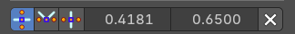
Vector Handle
Set handle type to Vector.

Auto Handle
Set handle type to Auto.

Auto Clamped Handle
Set handle type to Auto Clamped.

X / Y value
The position of the selected curve point.

Delete
Deletes the selected curve point.

Outputs

Value
Standard float value output.

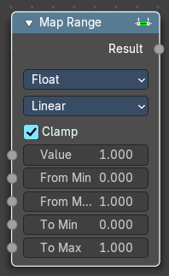
Map Range
This node allows to convert (map) an input value range into a destination range. By default, values outside the specified input range will be proportionally mapped as well. This node is similar to Map Value node but provides a more intuitive way to specify the desired output range.

Usage
One important use case is to easily map the original range of the Z-depth channel to a more usable range (i.e: 0.0 - 1.0) for use as a matte for colorization or filtering operations.

Inputs
This chapter deals with the input type Float. The same node exists in the Vector menu too. With preselected type Vector.

Value
Standard value input.

From Min/Max
Start/End of the input value range.

To Min/Max
Start/End of the destination range.

Steps
The amount of steps.
Note: Only shows when using the Stepped Linear interpolation type.

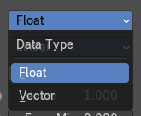
Properties

Data Type
Selects between float or vector values to map the range.

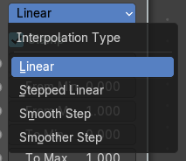
Interpolation Type
Selects between a linear, stepped linear, smooth step or smoother step interpolation types.

Clamp
Clamps values to Min/Max of the destination range.

Outputs

Value
Standard value output.

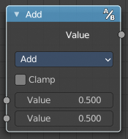
Math
The Math Node performs math operations.

Inputs

Value
First numerical value. The trigonometric functions accept values in radians.

Value
Second numerical value. This value is not used in functions that accept only one parameter like the trigonometric functions, Round and Absolute.

Properties

Operation
Here you can choose what mathematical operation to perform.
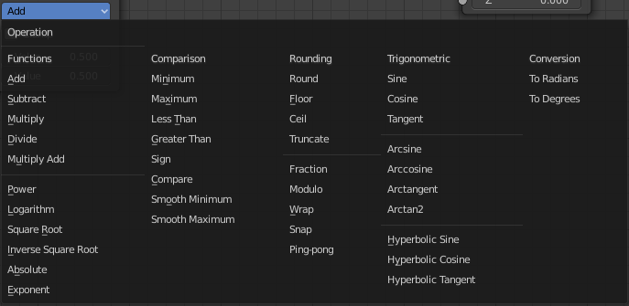

Clamp
Limits the output to the range (0 to 1). See clamp.

Outputs

Value
Numerical value output.

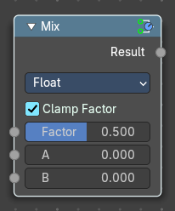
Mix
The Mix Node mixes float values by working on the individual and corresponding pixels of the two input values. Called “Mix” in the shader, Geometry Nodes and texture context.

Inputs

Factor
Controls the amount of influence the node exerts on the output Value.

Value A
The back value.

Value B
The top value.

Properties

Clamp Factor
Limit the highest color value to not exceed 1.

Outputs

Result
Value output.

